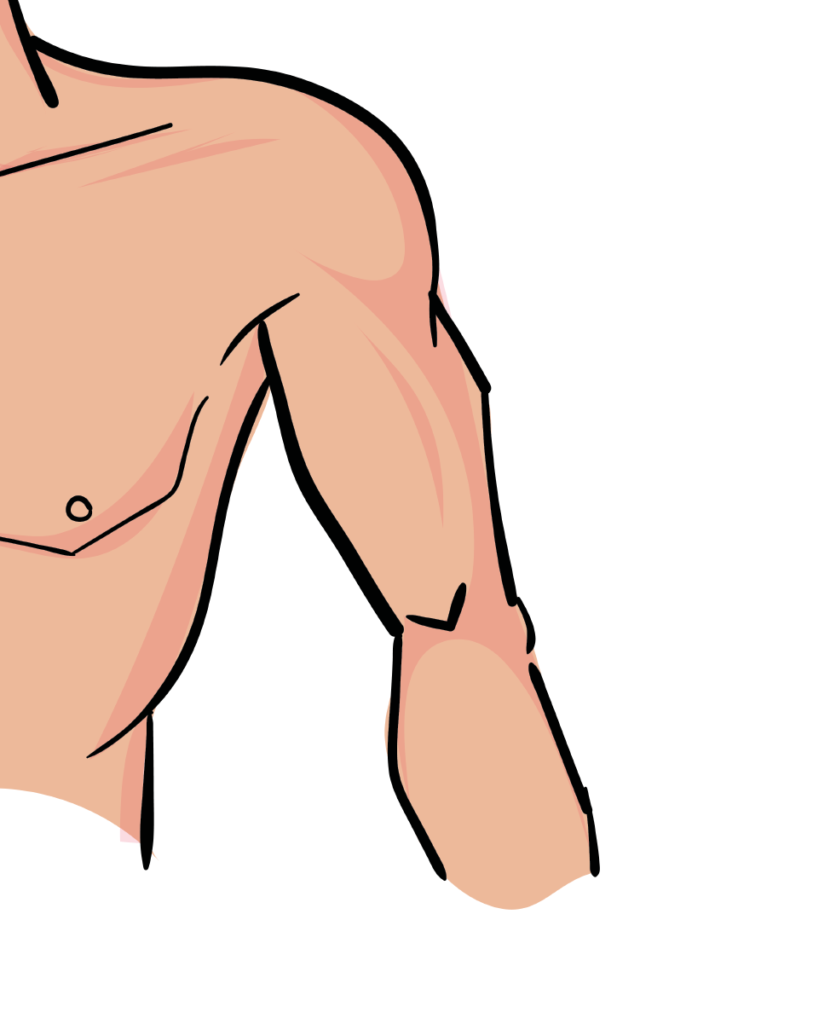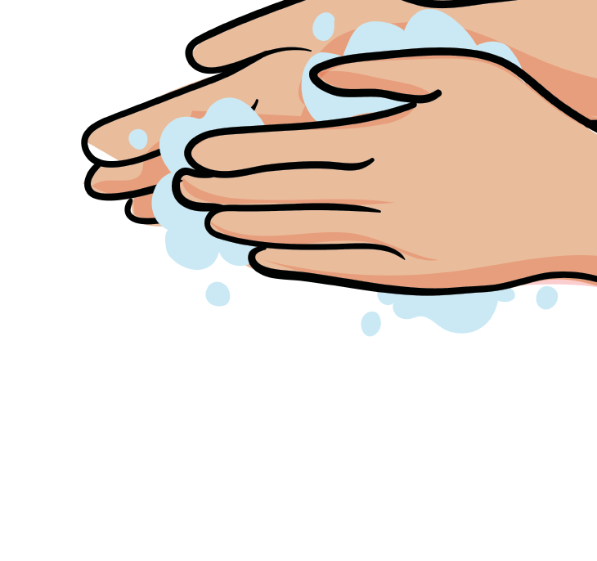Animals includig Hmans Knowledge Organiser
Animals including Humans Knowledge Organiser

How humans change
All living things have basic needs.
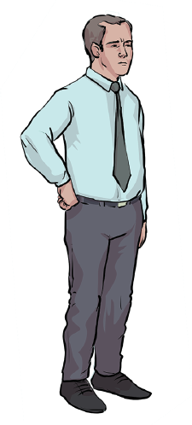They all need food, water and air to survive.
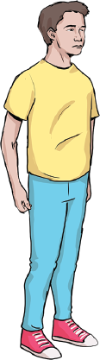
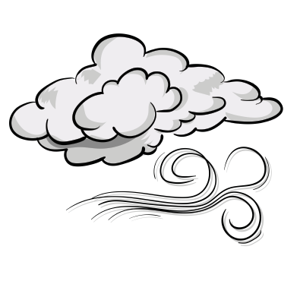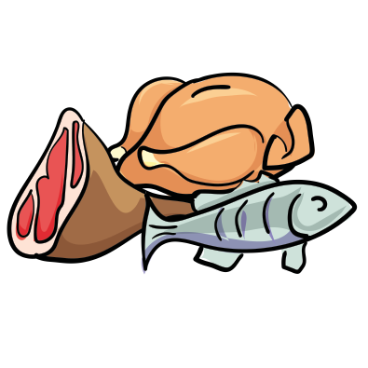
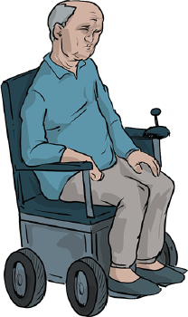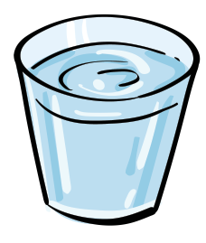
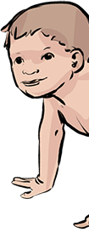

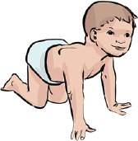

The life cycle of a butterfly
baby
child teenager adult senior

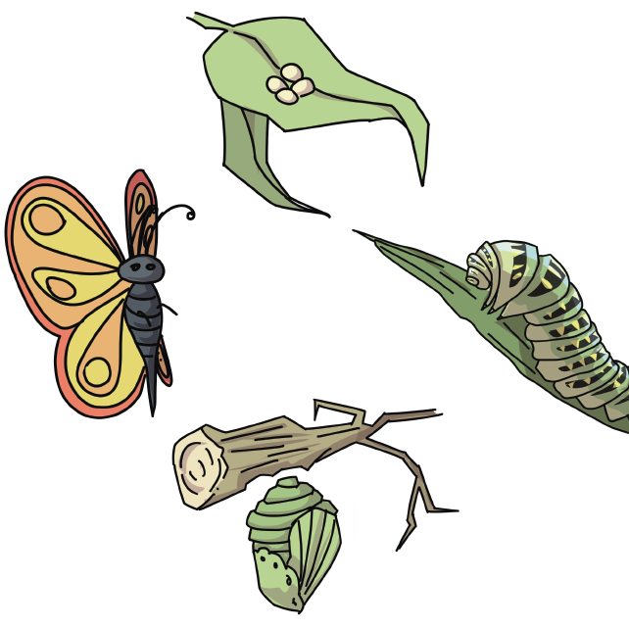

How can we look after ourselves?

egg
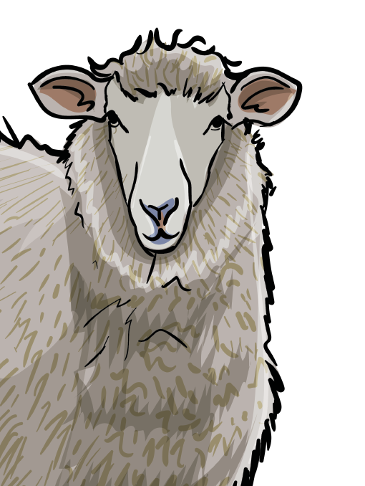
caterpillar

We can exercise regularly, eat a healthy diet
and make sure we have good hygiene.

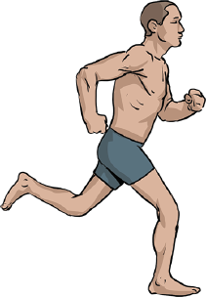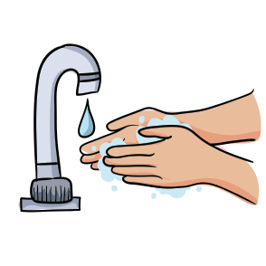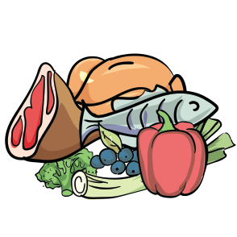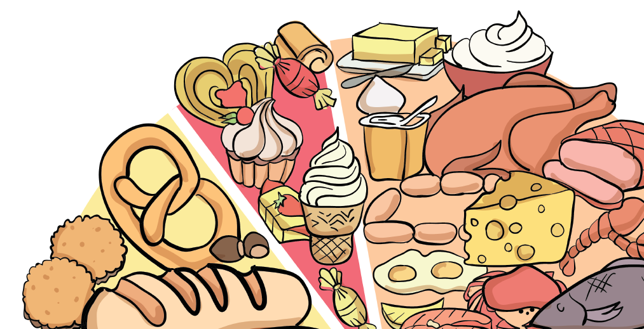

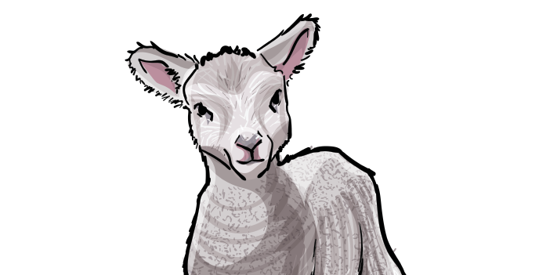

butterfly chrysalis

www.grammarsaurus.co.uk

Offspring Key Vocabulary

All animals including humans reproduce and have offspring. This means they make another one of the same species.

How do different animals produce their offspring?
basic needs - the important things that animals need to survive (air, water and food)
change - when something becomes different

diet - the food that an animal eats

exercise - when you complete an activity that increases your heart rate
healthy - good for you

hygiene - being clean in order to prevent illnesses

life cycle - the stages an animal goes through throughout

mammals amphibians fish
birds reptiles
lay eggs on land

babies grow in the mother’s womb

lay eggs in water
their life

offspring - the babies that an animal produces

reproduce - to produce offspring

species - a group

survive - to stay alive

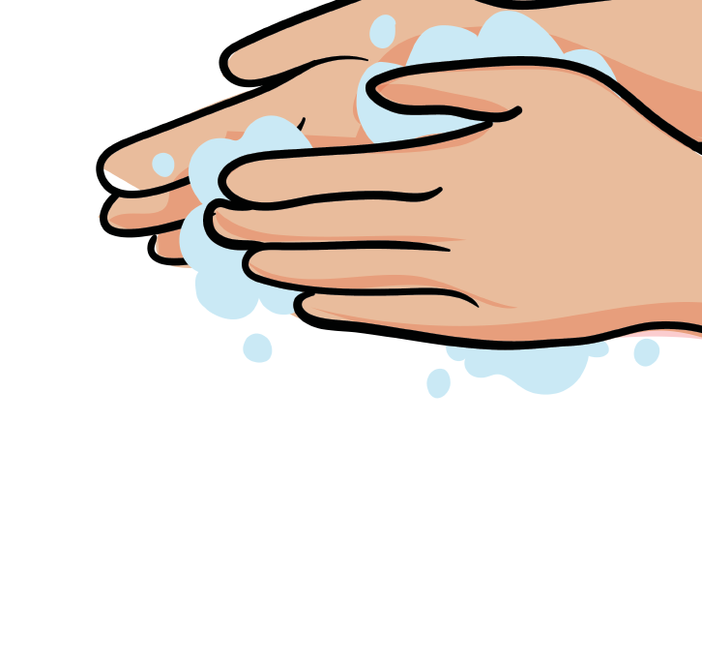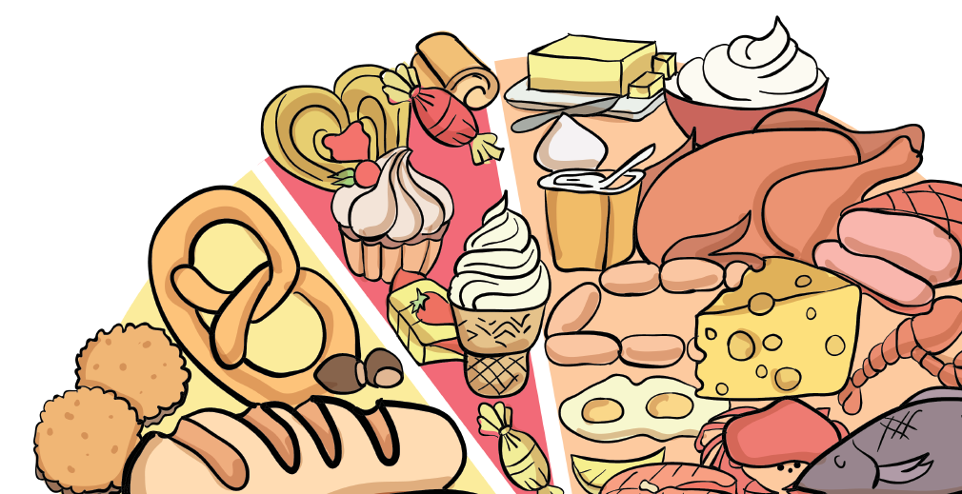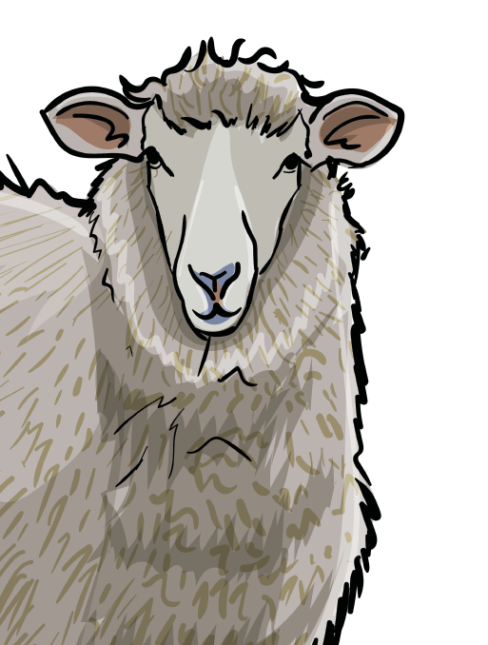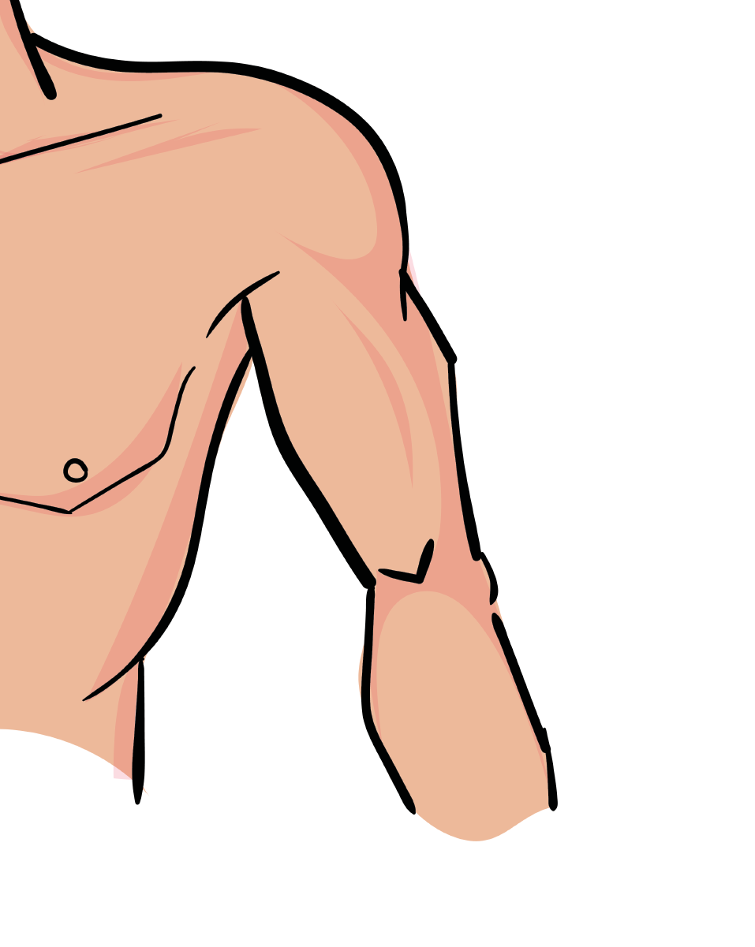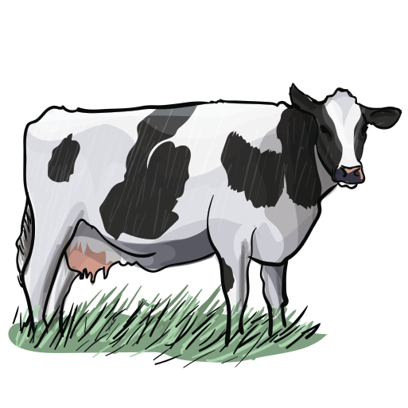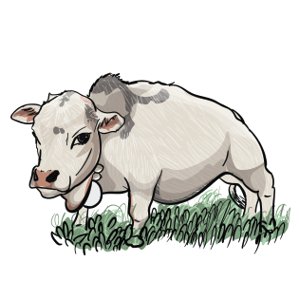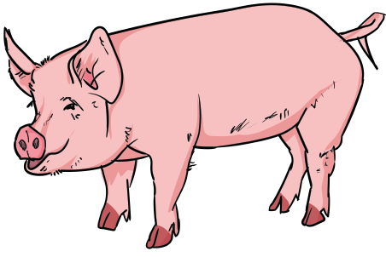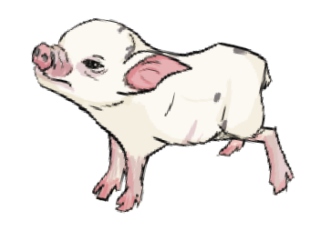

www.grammarsaurus.co.uk

